  NBA Player Performance Prediction Using Machine Learning and Statistical Analysis | Anubhav Roy  MSc Statistics

Abstract
The rapid growth of sports analytics has transformed the way player performance is evaluated, with data-driven approaches becoming an essential component in decision-making processes for teams, analysts, and researchers. Basketball generates extensive amounts of performance data through individual game statistics, providing opportunities to apply statistical techniques and machine learning methods for predictive modelling. This project focuses on developing a predictive framework to estimate NBA player scoring performance using historical game-level data and statistical learning approaches.
The primary objective of this study is to predict a player's points scored in a future game based on previously available performance information. Player game logs were collected using the NBA API, containing match-level statistics such as points scored, minutes played, field goal attempts, rebounds, assists, and other performance indicators. The dataset was processed and transformed into a structured format suitable for predictive modelling. Data preprocessing involved sorting observations chronologically, handling missing values, and constructing meaningful features that represent player form and consistency.
Feature engineering was performed to convert raw game statistics into predictive variables that would realistically be available before a game. Rolling averages based on the previous five games were created to capture short-term player performance trends, including recent scoring average, minutes played, assists, rebounds, and shot attempts. Additionally, a cumulative season average calculated using only previous games was incorporated to represent a player's established scoring ability while preventing data leakage. Previous game performance was also included as a feature to examine the effect of recent match outcomes on future scoring.
Exploratory Data Analysis (EDA) was conducted to understand patterns and relationships within the dataset. Statistical summaries and visualizations were used to examine scoring distributions, player consistency, and relationships between historical performance indicators and future scoring outcomes. These analyses helped identify important variables influencing player performance and guided the development of predictive models.
Two machine learning approaches were implemented and compared in this study. Multiple Linear Regression was used as a statistical baseline model to evaluate the relationship between engineered performance variables and player scoring output. Random Forest Regression was then applied as an ensemble machine learning technique capable of capturing non-linear relationships between player characteristics and scoring performance. The models were evaluated using performance metrics including Mean Absolute Error (MAE), Root Mean Squared Error (RMSE), and the coefficient of determination (R²).
The results demonstrated that historical performance trends provide significant predictive value for estimating future scoring outcomes. The Linear Regression model achieved an R² value of approximately 0.52 with a Mean Absolute Error of around 5 points, indicating that a substantial portion of variation in player scoring could be explained using previous performance indicators. Random Forest Regression produced comparable performance, highlighting that the relationship between historical player statistics and scoring output was relatively stable and could be effectively modelled using statistical approaches.
Feature importance analysis revealed that a player's season scoring average before a particular game was the most influential predictor of future points scored. Recent playing time, scoring form, shot attempts, rebounds, and assists also contributed to the prediction process, demonstrating the importance of both long-term player ability and short-term performance trends.
This project demonstrates the application of statistical modelling and machine learning techniques in the field of sports analytics. By combining historical data analysis, feature engineering, and predictive algorithms, the study provides a framework for understanding and forecasting individual player performance. Future improvements may include incorporating additional contextual variables such as opponent defensive strength, home-away advantage, injury status, team pace, and advanced basketball metrics to enhance prediction accuracy.
Keywords: Sports Analytics, NBA, Machine Learning, Linear Regression, Random Forest Regression, Predictive Modelling, Player Performance Analysis, Statistical Learning.

Introduction
The integration of data science and sports has significantly changed the way player performance is analysed, evaluated, and predicted. In modern basketball, teams and analysts increasingly rely on statistical methods and machine learning techniques to extract meaningful insights from large volumes of performance data. The National Basketball Association (NBA) produces extensive game-level data containing information about player contributions, playing patterns, and performance trends. This availability of structured data provides an opportunity to develop predictive models that can assist in understanding and forecasting individual player outcomes.
Player scoring performance is one of the most important aspects of basketball analysis, as points scored directly influence team success and player evaluation. However, predicting the number of points a player will score in a future game is a challenging problem because performance is influenced by several factors, including recent form, playing time, shot volume, consistency, and variations in game conditions. A player's previous performances can provide valuable information, but short-term fluctuations and game-to-game variability make accurate prediction difficult.
This project aims to develop a statistical and machine learning-based framework for predicting NBA player scoring performance using historical game data. The study focuses on predicting the points scored by a player in a future game based on information available from previous games. Instead of relying only on individual match statistics, the project incorporates feature engineering techniques to construct variables that represent player form and performance trends.
Game-level player statistics were collected using the NBA API, containing variables such as points scored, minutes played, field goal attempts, rebounds, and assists. The raw data was processed and transformed into a structured dataset suitable for predictive modelling. Historical performance indicators were generated using rolling averages from previous games, allowing the model to capture recent player form. A cumulative season average calculated only from previous games was also included to represent a player's established scoring ability while avoiding the problem of data leakage.
Statistical modelling techniques were applied to analyse the relationship between historical player performance and future scoring outcomes. Multiple Linear Regression was implemented as a baseline statistical model to understand the contribution of different performance indicators towards scoring prediction. Additionally, Random Forest Regression was used as a machine learning approach to identify possible non-linear relationships between player statistics and scoring performance.
The developed models were evaluated using performance metrics such as Mean Absolute Error (MAE), Root Mean Squared Error (RMSE), and the coefficient of determination (R²). These metrics were used to compare model accuracy and determine how effectively historical player information could explain variations in future scoring performance. Feature importance analysis was also performed to identify the most influential factors affecting scoring predictions.
The significance of this study lies in demonstrating how statistical analysis and machine learning can be applied in the field of sports analytics. By combining historical performance analysis, predictive modelling, and data-driven feature extraction, the project provides insights into the factors that influence NBA player scoring performance. The developed framework can serve as a foundation for future improvements involving additional variables such as opponent strength, player injuries, team pace, and advanced basketball metrics.

Why NBA Analytics?
The National Basketball Association (NBA) is one of the most data-driven sports leagues in the world, generating a large amount of statistical information from every game played. Modern basketball analysis has moved beyond traditional observations such as points scored and wins, with teams increasingly relying on advanced statistics and analytical models to evaluate players, understand performance patterns, and make strategic decisions.
Player performance in basketball is influenced by multiple factors, including scoring ability, playing time, shooting efficiency, recent form, and overall contribution to the team. Due to the dynamic nature of the sport, a player's performance can vary significantly from one game to another. This creates an interesting statistical problem: identifying patterns in historical data that can help predict future outcomes.
NBA analytics provides an ideal environment for applying statistical and machine learning techniques because of the availability of detailed game-level data. Each player's performance can be represented through multiple variables such as points scored, minutes played, field goal attempts, rebounds, and assists. These variables allow researchers to investigate relationships between past performance indicators and future player outcomes.
Predicting player scoring performance has practical importance in several areas. Teams can use predictive models to support player evaluation, workload management, and strategic planning. Analysts can use these models to identify trends and assess consistency, while fantasy basketball platforms can utilize predictions to estimate future player value. From a statistical perspective, NBA data provides an opportunity to explore regression techniques, feature engineering, and predictive modelling using real-world sports data.
The complexity of basketball also makes it a suitable domain for machine learning applications. Unlike simple statistical summaries, predictive models can identify hidden patterns and interactions among multiple performance variables. Factors such as recent performance trends, season-long consistency, and player involvement in offensive plays can be combined to develop models capable of estimating future scoring output.
This project uses NBA analytics as a case study to demonstrate how statistical methods and machine learning algorithms can be applied to sports performance prediction. By analysing historical player data and developing predictive models, the study aims to understand the factors that influence scoring performance and evaluate the effectiveness of different modelling approaches in forecasting NBA player outcomes.

Data Description and Source
Data Source
The dataset used in this project was obtained through the NBA API using the Python package nba_api. The NBA API provides access to publicly available basketball statistics, including player information, team details, and game-level performance data from the National Basketball Association (NBA). The API was used to collect individual player game logs containing detailed performance statistics for predictive analysis.
The data was extracted in a structured format and converted into a tabular dataset suitable for statistical analysis and machine learning modelling. Each observation in the dataset represents the performance of a particular NBA player in a single game, making the dataset a player-game level dataset.

Data Description
The dataset consists of historical NBA player game statistics, where the objective is to predict the number of points scored by a player in a future game using information from previous performances.
The main response variable considered in this study is:
Points (PTS):
- Represents the total number of points scored by a player in a particular game.
- This variable is treated as the target variable for prediction.
The dataset contains several performance-related variables, including:
Player Information
- PLAYER_NAME: Name of the NBA player.
- TEAM: Team represented by the player.
- SEASON: NBA season corresponding to the game.
- GAME_DATE: Date on which the game was played.
Game Performance Variables
- MIN (Minutes Played): Total minutes played by the player in the game.
- FGA (Field Goal Attempts): Number of field goal attempts taken.
- FG_PCT (Field Goal Percentage): Shooting efficiency from field goal attempts.
- FG3A (Three-Point Attempts): Number of three-point shots attempted.
- FG3_PCT (Three-Point Percentage): Efficiency from three-point shooting.
- FTA (Free Throw Attempts): Number of free throws attempted.
- REB (Rebounds): Total rebounds collected.
- AST (Assists): Total assists recorded.
- STL (Steals): Number of steals.
- BLK (Blocks): Number of blocks.
- TOV (Turnovers): Number of turnovers committed.

Feature Engineering Variables
To make the prediction problem more realistic, additional features were created using historical performance data. These variables were generated using only information available before the predicted game.
The engineered features include:
- Last 5 Games Average Points: Average points scored by the player over the previous five games, representing recent scoring form.
- Last 5 Games Average Minutes: Average playing time over the previous five games.
- Last 5 Games Average Assists: Average assists over the previous five games.
- Last 5 Games Average Rebounds: Average rebounds over the previous five games.
- Last 5 Games Average Field Goal Attempts: Average shot volume over the previous five games.
- Previous Game Points: Points scored by the player in the immediately preceding game.
- Season Average Points Before Game: Cumulative average points scored by the player before the prediction game, used to represent established scoring ability while avoiding data leakage.
After preprocessing and feature engineering, the final dataset was used to develop regression-based predictive models for estimating future NBA player scoring performance.

Objectives of the Study
The primary objective of this study is to develop a statistical and machine learning-based framework for predicting NBA player scoring performance using historical game-level data. The study aims to analyse player performance patterns and identify important factors that influence future scoring outcomes.
The specific objectives of the study are:
- To collect and preprocess NBA player game-level data
  - To obtain historical player performance statistics using the NBA API and transform the raw data into a structured dataset suitable for analysis.
- To perform exploratory data analysis on NBA player performance data
  - To examine scoring patterns, player consistency, and relationships between different performance variables through statistical summaries and visualizations.
- To engineer meaningful predictive features from historical game statistics
  - To create variables such as recent five-game averages, previous game performance, and cumulative season averages that represent player form and scoring ability.
- To develop a predictive model for NBA player scoring performance
  - To use statistical and machine learning techniques to predict the number of points a player is expected to score in a future game.
- To implement and compare different regression-based modelling approaches
  - To apply Multiple Linear Regression and Random Forest Regression and evaluate their effectiveness in predicting player scoring outcomes.
- To evaluate model performance using appropriate statistical metrics
  - To assess the accuracy of the developed models using Mean Absolute Error (MAE), Root Mean Squared Error (RMSE), and the coefficient of determination (R²).
- To identify the key factors influencing player scoring performance
  - To analyse feature importance and determine which historical performance indicators contribute most significantly to predicting future points scored.
- To demonstrate the application of statistical learning techniques in sports analytics
  - To highlight how data-driven methods can be used for performance evaluation and decision-making in professional basketball.

Limitations of the Study
Although the study demonstrates the application of statistical and machine learning techniques for predicting NBA player scoring performance, there are certain limitations that affect the accuracy and generalizability of the developed models.
- Limited Feature Availability
  - The prediction models are primarily based on player game statistics such as points, minutes, assists, rebounds, and shooting-related variables. Important external factors such as opponent defensive strength, player injuries, team strategies, game pace, and lineup changes were not included.
- Prediction Limited to Scoring Performance
  - The study focuses only on predicting the number of points scored by a player. Other aspects of player contribution, such as defensive impact, efficiency, decision-making, and overall player value, are not considered.
- Game-to-Game Performance Variability
  - Basketball performance can fluctuate significantly due to factors such as match conditions, foul trouble, coaching decisions, and changes in player roles. These unpredictable elements introduce uncertainty into the prediction process.
- Absence of Advanced Basketball Metrics
  - Advanced statistics such as Player Efficiency Rating (PER), Usage Rate, True Shooting Percentage (TS%), and other analytical measures were not incorporated, which may have provided additional insights into player performance.
- Model Dependency on Historical Data
  - The models assume that past performance trends provide useful information about future performance. However, player form, team situations, and playing roles can change over time, reducing the effectiveness of historical patterns.
- Dataset Scope
  - The analysis is based on available NBA game-level data collected through the NBA API. Differences in player availability, number of games played, and changes across NBA seasons may influence the consistency of the dataset.
- Limited Model Exploration
  - The study compares only Linear Regression and Random Forest Regression models. Other advanced machine learning techniques such as Gradient Boosting, XGBoost, Neural Networks, and time-series models could be explored in future studies.
- Prediction Accuracy Constraints
  - Since the model attempts to predict individual game performance, achieving perfect accuracy is challenging due to the unpredictable nature of sports. The developed models provide statistical estimates rather than guaranteed outcomes.
Despite these limitations, the study provides a foundation for applying statistical modelling and machine learning techniques to NBA performance analysis and demonstrates the potential of data-driven approaches in sports analytics.

Methodology
The methodology adopted in this study involves a systematic approach consisting of data collection, preprocessing, exploratory data analysis, feature engineering, predictive modelling, and model evaluation. The objective is to develop statistical and machine learning models capable of predicting NBA player scoring performance using historical game-level data.
1. Data Collection
The first stage involved collecting NBA player game-level statistics using the NBA API through the Python package nba_api. The collected data consisted of individual player performances across multiple NBA seasons, where each observation represented a player's statistics in a particular game. The dataset included variables related to scoring, shooting efficiency, playing time, and overall game contribution.
The collected statistics included:
- Points scored (PTS)
- Minutes played (MIN)
- Field goal attempts (FGA)
- Free throw attempts (FTA)
- Three-point attempts (FG3A)
- Rebounds (REB)
- Assists (AST)
- Steals (STL)
- Blocks (BLK)
- Turnovers (TOV)

2. Data Preprocessing
The raw dataset was processed to make it suitable for statistical modelling. The preprocessing steps included:
- Data sorting:
The observations were arranged chronologically based on player name and game date to maintain the correct sequence of player performances.
- Missing value treatment:
Missing observations were identified and removed where necessary. Missing values mainly occurred during feature creation because early games did not contain enough historical data for calculating rolling averages.
- Data leakage prevention:
Features were carefully constructed using only information available before the prediction game. Season averages and rolling statistics were shifted by one game to ensure that future information was not included during model training.

3. Exploratory Data Analysis (EDA)
Exploratory Data Analysis was performed to understand the distribution of player performance variables and identify important relationships within the dataset. Statistical summaries and visualizations were used to examine:
- Distribution of points scored by players
- Relationship between recent performance and future scoring
- Variation in player statistics across games
- Contribution of different performance indicators towards scoring output
EDA helped identify patterns and guided the selection of appropriate features for predictive modelling.

4. Feature Engineering
Feature engineering was performed to transform raw game statistics into meaningful predictive variables. Since the objective was to predict future scoring performance, features were created using only previous games.
The engineered features included:
- Last 5 Games Average Points: Captures recent scoring form.
- Last 5 Games Average Minutes: Represents recent playing time and role.
- Last 5 Games Average Assists: Represents recent playmaking contribution.
- Last 5 Games Average Rebounds: Represents overall involvement.
- Last 5 Games Average Field Goal Attempts: Represents offensive involvement and shot volume.
- Previous Game Points: Captures immediate past performance.
- Season Average Points Before Game: Represents long-term scoring ability while avoiding future information leakage.

5. Predictive Modelling
Two regression-based approaches were implemented to predict NBA player scoring performance.
Multiple Linear Regression
Multiple Linear Regression was used as a baseline statistical model to analyse the relationship between historical performance variables and future points scored. The model assumes that the target variable can be explained through a linear combination of the selected predictor variables.
Random Forest Regression
Random Forest Regression was applied as a machine learning approach to capture possible non-linear relationships between player performance features and scoring outcomes. The model combines multiple decision trees to improve prediction performance and reduce overfitting.

6. Model Evaluation
The performance of the developed models was evaluated using standard regression metrics:
Mean Absolute Error (MAE)
Measures the average absolute difference between actual and predicted points.
Root Mean Squared Error (RMSE)
Measures prediction error while assigning greater importance to larger errors.
Coefficient of Determination (R² Score)
Measures the proportion of variation in player scoring performance explained by the model.
The models were compared based on these evaluation metrics to determine their effectiveness in predicting NBA player scoring performance.

7. Feature Importance Analysis
Feature importance analysis was performed to identify the variables that contributed most significantly to the prediction process. This analysis helped determine whether long-term player ability, recent form, or other performance indicators had the greatest influence on future scoring predictions.
Through this methodology, the study combines statistical analysis and machine learning techniques to develop a data-driven approach for understanding and predicting NBA player performance.

Exploratory Data Analysis
Exploratory Data Analysis (EDA) was performed to understand the underlying patterns, distributions, and relationships present in the NBA player performance dataset before applying predictive modelling techniques. The primary purpose of EDA was to identify important trends in player scoring performance, examine relationships between variables, and gain insights that would guide feature selection and model development.
1. Analysis of Points Scored Distribution
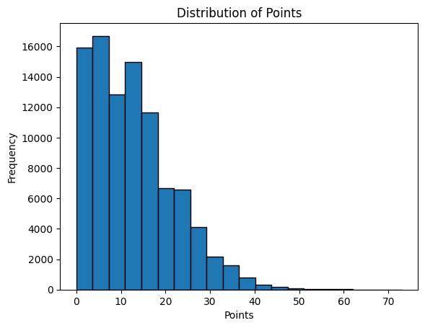

The distribution of player points scored was analysed to understand the scoring patterns within the dataset. The analysis showed that most player performances were concentrated around lower scoring ranges, while a smaller number of observations represented high-scoring performances. This indicates that NBA scoring data contains variability, with occasional high-scoring games produced by elite offensive players.
Understanding this distribution was important because the target variable, points scored (PTS), forms the basis of the prediction problem.

2. Analysis of Player Performance Statistics
Descriptive statistics were calculated for major performance variables such as minutes played, field goal attempts, rebounds, assists, and points scored. These summaries provided information about:
- Average player contribution per game
- Variation in player performances
- Range of values for different statistical variables
The analysis showed that variables related to offensive involvement, such as minutes played and field goal attempts, were closely associated with scoring output.

3. Relationship Between Recent Form and Scoring Performance
Since the objective of the study was to predict future player scoring, recent performance trends were analysed. Rolling averages based on the previous five games were examined to understand whether recent form had an influence on future points scored.
A positive relationship was observed between recent average points and future game scoring, suggesting that players who consistently score higher in recent games are more likely to maintain similar scoring levels in subsequent games.

4. Correlation Analysis
Correlation analysis was conducted to examine the strength and direction of relationships between numerical variables.
Important observations included:
- Points scored showed a positive association with offensive involvement variables such as field goal attempts and playing time.
- Players with higher shot volume generally recorded higher scoring outputs.
- Recent performance indicators showed meaningful relationships with future scoring.
The correlation analysis helped identify variables that could contribute to the predictive modelling process.

5. Feature Importance Analysis
After developing machine learning models, feature importance analysis was performed to identify the variables that contributed most to predicting player scoring performance.
The analysis showed that:
- Season average points before a game was the most influential predictor.
- Recent minutes played and recent scoring averages also contributed significantly.
- Recent assists, rebounds, and shot attempts provided additional predictive information.
This indicated that both long-term player ability and short-term performance trends influence future scoring outcomes.

6. Key Insights from EDA
The exploratory analysis provided several important insights:
- Player scoring ability shows consistency over time, making historical performance useful for prediction.
- Offensive involvement, particularly playing time and shot attempts, plays an important role in scoring output.
- Recent performance trends provide additional information beyond overall player averages.
- No single statistic completely determines scoring performance, highlighting the need for predictive models that combine multiple variables.
The findings from EDA supported the selection of regression-based statistical and machine learning models for predicting NBA player scoring performance.

Statistical Analysis
Statistical analysis was performed to understand the relationships between player performance variables and future scoring outcomes before developing predictive models. The analysis focused on examining descriptive statistics, relationships among variables, and evaluating the contribution of different performance indicators towards predicting NBA player scoring performance.
1. Descriptive Statistical Analysis
Descriptive statistics were calculated for the major variables in the dataset to summarize player performance patterns. Measures such as mean, standard deviation, minimum, maximum, and quartiles were analysed for variables including points scored, minutes played, field goal attempts, rebounds, and assists.
This analysis helped in understanding:
- The average scoring output of players.
- The variability in player performances across games.
- The distribution and range of different performance statistics.
The descriptive analysis indicated that NBA player performance varies considerably between games, with elite players producing consistently higher scoring outputs compared to lower-volume players.

2. Correlation Analysis
Correlation analysis was conducted to measure the strength and direction of relationships between numerical variables. The Pearson correlation coefficient was used to examine associations between player statistics and scoring performance.
The analysis focused on identifying variables that showed meaningful relationships with points scored.
Key observations included:
- Field Goal Attempts (FGA): A positive relationship was observed, indicating that players with greater shooting volume tend to score more points.
- Minutes Played (MIN): A positive association was identified, as players receiving more playing time generally have more opportunities to contribute offensively.
- Recent Average Points: Showed a positive relationship with future scoring, suggesting that recent player form provides useful predictive information.
- Assists and Rebounds: Although primarily non-scoring statistics, they provided additional information regarding overall player involvement.

3. Regression Analysis
Regression analysis was used to model the relationship between historical player performance indicators and future points scored.

Multiple Linear Regression
Multiple Linear Regression was initially applied as a baseline statistical model. The model examined how a combination of predictor variables influenced the target variable, points scored.
The predictors included:
- Recent average points
- Recent average minutes
- Recent average assists
- Recent average rebounds
- Season average points before game
- Previous game points
- Recent average field goal attempts
The model helped quantify the contribution of each predictor and provided an interpretable relationship between historical performance and scoring outcomes.

4. Model Evaluation Metrics
The performance of regression models was assessed using standard statistical measures:
Mean Absolute Error (MAE)
MAE was used to measure the average absolute difference between actual and predicted points. It provides an intuitive understanding of prediction error in terms of points per game.

Root Mean Squared Error (RMSE)
RMSE was calculated to measure the magnitude of prediction errors while giving greater importance to larger deviations between predicted and actual values.
Coefficient of Determination (R²)
The R² value was used to determine the proportion of variation in player scoring performance explained by the model. A higher R² value indicates that the selected predictor variables explain a greater amount of variation in scoring outcomes.

5. Feature Contribution Analysis
Feature contribution analysis was performed using both regression coefficients and Random Forest feature importance scores.
The analysis revealed that:
- Season average points calculated before the prediction game was the strongest predictor of future scoring.
- Recent playing time and scoring trends contributed additional predictive value.
- Short-term indicators such as previous game points had limited influence when compared with long-term player performance.
This analysis demonstrated that a combination of established player ability and recent performance trends provides a more effective approach for predicting NBA scoring outcomes.

Overall, the statistical analysis established the relationship between historical player performance and future scoring ability. The findings supported the use of regression-based predictive models and provided insights into the factors that influence NBA player scoring performance.

Predictive Modelling and Machine Learning
Predictive modelling was performed to develop a data-driven framework for estimating NBA player scoring performance using historical game statistics. The objective was to use previously available player performance information to predict the number of points a player would score in a future game. Two regression-based approaches were implemented: Multiple Linear Regression as a statistical baseline model and Random Forest Regression as a machine learning model.
1. Data Preparation for Modelling
Before developing predictive models, the dataset was prepared by selecting relevant predictor variables and separating the input features from the target variable.
The target variable considered in this study was:
Points Scored (PTS)
- Represents the actual number of points scored by a player in a particular game.
The predictor variables included:
- Last 5 Games Average Points
- Last 5 Games Average Minutes
- Last 5 Games Average Assists
- Last 5 Games Average Rebounds
- Last 5 Games Average Field Goal Attempts
- Previous Game Points
- Season Average Points Before Game
The dataset was divided into training and testing subsets to evaluate the performance of the developed models on unseen data.

2. Multiple Linear Regression Model
Multiple Linear Regression was implemented as the first predictive model. It is a statistical technique used to analyse the relationship between a dependent variable and multiple independent variables.
The model estimates the contribution of each predictor variable towards the target variable, allowing interpretation of how different performance indicators influence player scoring.
The general form of the model is:
Points Scored = β₀ + β₁X₁ + β₂X₂ + ... + βₙXₙ + ε
where:
- β₀ represents the intercept.
- β₁, β₂, ..., βₙ represent the coefficients of predictor variables.
- X represents the selected performance features.
- ε represents the random error component.
The model was evaluated using Mean Absolute Error (MAE), Root Mean Squared Error (RMSE), and R² score.
The final Linear Regression model achieved:
- Mean Absolute Error (MAE): 4.98 points
- Root Mean Squared Error (RMSE): 6.43 points
- R² Score: 0.517
This indicates that approximately 51.7% of the variation in player scoring performance was explained by the selected historical performance variables.

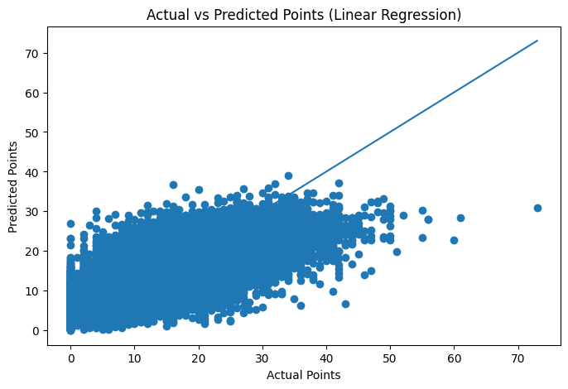
Interpretation:
The scatter plot demonstrates the relationship between actual and predicted scoring values. Points closer to the diagonal line indicate more accurate predictions.

3. Random Forest Regression Model
Random Forest Regression was implemented as a machine learning approach to capture possible non-linear relationships between player statistics and scoring performance.
Random Forest is an ensemble learning technique that combines multiple decision trees to produce a final prediction. Each tree learns different patterns from the data, and the final output is obtained by averaging predictions from all individual trees.
The advantages of using Random Forest include:
- Ability to model complex relationships.
- Reduced risk of overfitting compared to individual decision trees.
- Capability to identify important predictive features.
The Random Forest model was trained using the same set of predictor variables used in the Linear Regression model.
The model performance was:
- Mean Absolute Error (MAE): 5.09 points
- Root Mean Squared Error (RMSE): 6.57 points
- R² Score: 0.495
The performance was comparable to Linear Regression but slightly lower, suggesting that the relationship between historical performance variables and scoring output was relatively stable and could be captured effectively using a simpler statistical model.

4. Feature Importance Analysis
Feature importance analysis was performed using the Random Forest model to determine which variables contributed most significantly to prediction accuracy.
The most influential features were:
- Season Average Points Before Game
- Last 5 Games Average Minutes
- Last 5 Games Average Points
- Last 5 Games Average Field Goal Attempts
- Last 5 Games Average Rebounds
- Last 5 Games Average Assists
- Previous Game Points
The analysis showed that a player's established scoring ability was the strongest factor influencing future scoring predictions. Recent playing time and performance trends provided additional predictive information.

5. Model Comparison
The performance of both models was compared using evaluation metrics.
Model | MAE | RMSE | R²
Multiple Linear Regression | 4.98 | 6.43 | 0.517
Random Forest Regression | 5.09 | 6.57 | 0.495

The results indicate that Multiple Linear Regression slightly outperformed Random Forest Regression. This suggests that the relationship between historical player statistics and scoring performance can be reasonably represented using linear relationships.
The predictive modelling stage demonstrates how statistical techniques and machine learning algorithms can be applied to sports analytics problems to estimate future player performance using historical data.

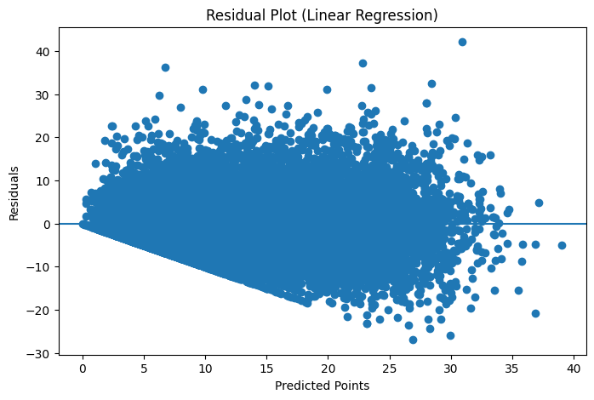
Interpretation:
The residual plot was used to examine the distribution of prediction errors. A random spread around zero indicates that the model does not show systematic prediction bias.

Results and Discussion
The objective of this study was to develop predictive models capable of estimating NBA player scoring performance using historical game-level statistics. Two regression-based approaches, Multiple Linear Regression and Random Forest Regression, were developed and evaluated using performance metrics including Mean Absolute Error (MAE), Root Mean Squared Error (RMSE), and the coefficient of determination (R²).
1. Model Performance Evaluation
The performance of both predictive models was evaluated on unseen test data to measure their ability to generalize beyond the training dataset.
Model | Mean Absolute Error (MAE) | Root Mean Squared Error (RMSE) | R² Score
Multiple Linear Regression | 4.98 | 6.43 | 0.517
Random Forest Regression | 5.09 | 6.57 | 0.495

The results indicate that both models were able to capture meaningful patterns in NBA player scoring performance. Multiple Linear Regression achieved slightly better performance compared to Random Forest Regression, with a lower MAE and RMSE and a higher R² score.
The Linear Regression model was able to explain approximately 51.7% of the variation in player scoring output using historical performance indicators. This suggests that previous player performance statistics contain significant predictive information regarding future scoring outcomes.

2. Analysis of Prediction Accuracy
The Mean Absolute Error of approximately 5 points indicates that the model's predictions differ from the actual scoring output by around five points on average. Considering the unpredictable nature of basketball games, this level of error is reasonable because individual player performances can be affected by several external factors such as defensive matchups, coaching decisions, injuries, foul trouble, and changes in playing time.
The RMSE values were slightly higher than MAE values for both models, indicating the presence of some larger prediction errors. These errors may occur in situations where players experience unusually high-scoring or low-scoring games compared to their historical trends.

3. Comparison Between Statistical and Machine Learning Models
The comparison between the two models provides an important insight into the relationship between player statistics and scoring performance.
Although Random Forest Regression is capable of capturing complex and non-linear patterns, it did not outperform Linear Regression in this study. This suggests that the relationship between historical performance variables and future scoring is relatively stable and can be represented effectively using linear relationships.
The Linear Regression model also provides greater interpretability, allowing direct analysis of how individual variables influence scoring predictions. This is particularly useful from a statistical perspective, where understanding the contribution of explanatory variables is important.

4. Feature Importance and Influencing Factors
Feature analysis revealed that Season Average Points Before Game was the most influential predictor of future scoring performance. This indicates that a player's established scoring ability is the strongest determinant of future scoring output.
Other important predictors included:
- Last 5 Games Average Minutes:
Playing time has a direct impact on scoring opportunities. Players receiving more minutes generally have more chances to contribute offensively.
- Last 5 Games Average Points:
Recent scoring form provides additional information about current player performance.
- Last 5 Games Average Field Goal Attempts:
Shot volume reflects offensive involvement and strongly influences scoring potential.
- Recent Rebounds and Assists:
These variables provide additional information about player involvement, although their direct impact on scoring was comparatively lower.

5. Statistical Interpretation
The findings demonstrate that NBA scoring performance is influenced mainly by consistent player characteristics rather than isolated game events. A player's long-term scoring ability combined with recent performance trends provides a reliable basis for predicting future outcomes.
The results also highlight the importance of proper feature construction. The use of season averages calculated only from previous games prevented data leakage and ensured that the model evaluation represented a realistic prediction scenario.

6. Overall Discussion
The study successfully demonstrates the application of statistical modelling and machine learning techniques in NBA sports analytics. The developed models were able to identify meaningful relationships between historical player performance and future scoring output.
While the models achieved moderate predictive performance, further improvements could be obtained by incorporating additional contextual variables such as opponent defensive rating, team pace, home-away advantage, injury information, player usage rate, and advanced basketball metrics.
Overall, the results show that historical performance data provides valuable predictive information, and statistical learning approaches can serve as effective tools for analysing and forecasting NBA player performance.

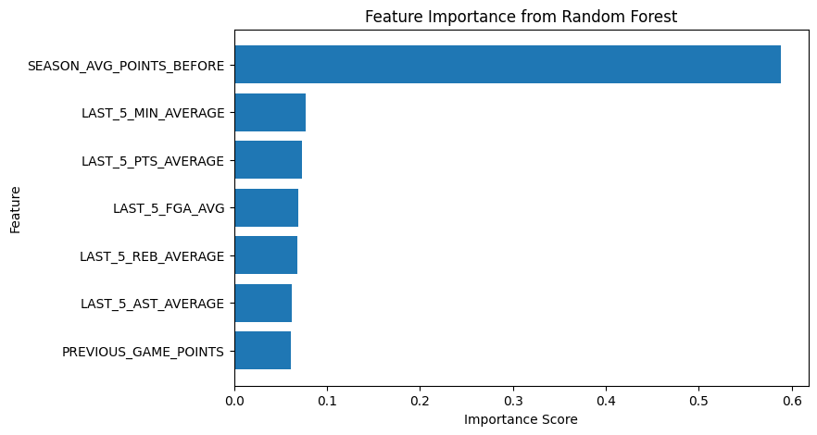
Random Forest Feature Importance Interpretation:
The feature importance analysis shows that Season Average Points Before Game is the most influential predictor of future scoring performance. Recent performance indicators such as average minutes, points, and field goal attempts also contribute significantly to the model. This indicates that both long-term scoring ability and recent player form play an important role in predicting NBA player points.

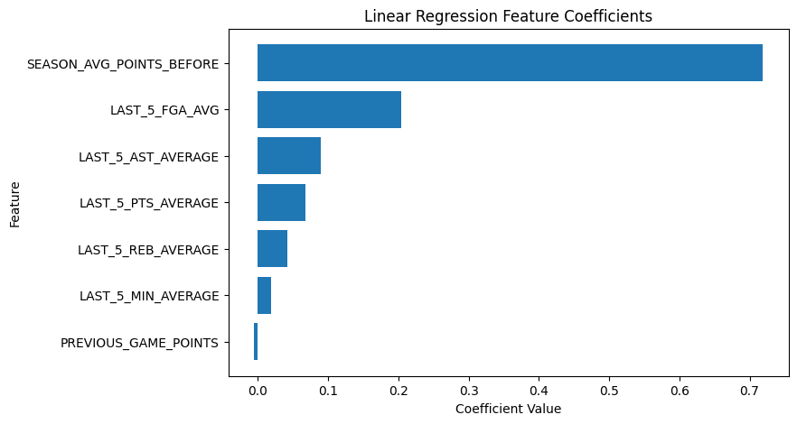
Linear Regression Coefficient Interpretation
The coefficient analysis shows that Season Average Points Before Game has the strongest positive influence on predicted points scored. Other recent performance variables also show positive contributions, indicating that consistent past performance helps improve prediction accuracy. The model highlights the relationship between historical player statistics and future scoring output.

